2.Write a program that find a given number is negative or positive.

Input = 123 output= Positive

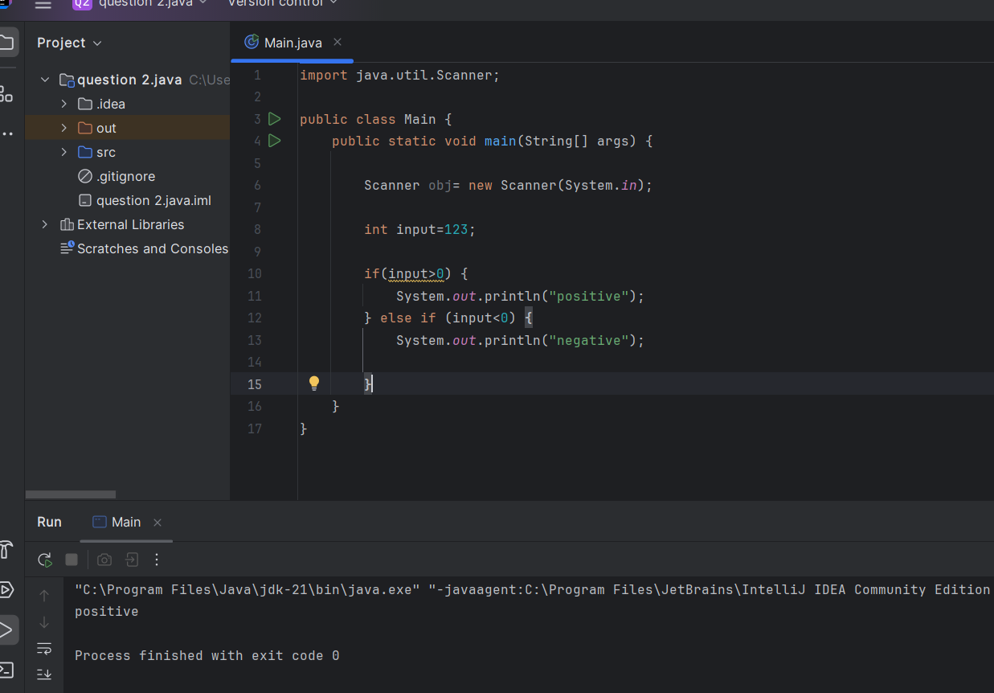

Input= -100 output=Negative

Input= -100 output=Negative

